TY B.Tech. (CSE) – II [2022-23]

5CS372: Advanced Database System Lab.

Assignment No. 4

Name : Tanaya Mukund Bhide

PRN : 2020BTECS00011

Batch : T5

Branch: T.Y CSE

Design and implement a system for managing online multiple-choice tests. The system should support distributed contribution of questions by teaching assistants, editing of the questions by whoever is in-charge of the course and creation of tests from the available set of questions. It should be able to administer the tests online, either at a fixed time for all students or at any time but with a time limit from start to finish and give students feedback on their scores at the end of the allotted time.

Note : The system should allow to give exam from mobile device also. Technology stack : ReactJS/NodeJS / MySQL or Oracle , Bootstrap v5.0, look and feel UI template Requirement Specifications :

1. User management at different levels (Teachers/students)

2. Question Bank Entry form with provision of accepting images / mathematical expressions

3. Generic report generation : Should able to display/list any data.

Creation of tables in the Mysql database named quiz

1.Student Table

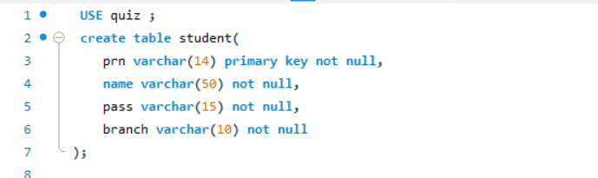

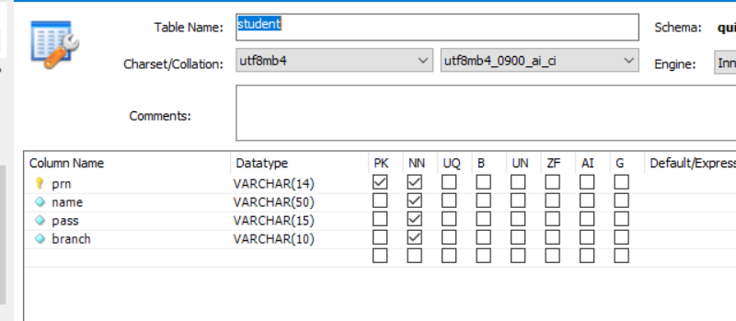

2 .Teacher Table

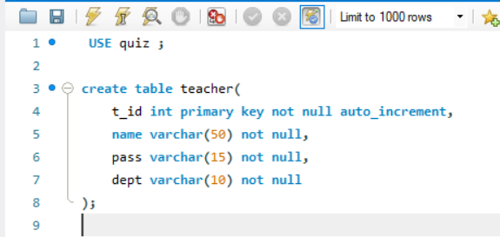

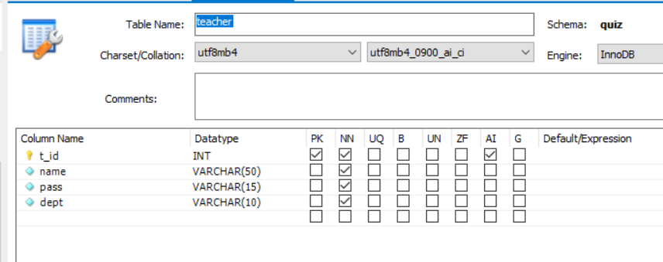

3. Quiz Table 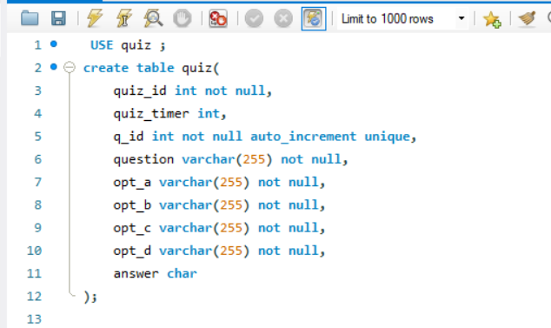

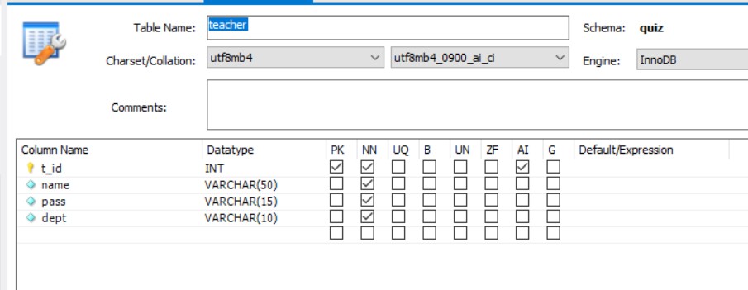

4. takes_quiz table

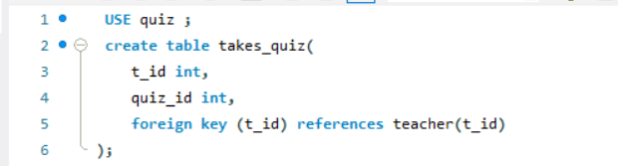

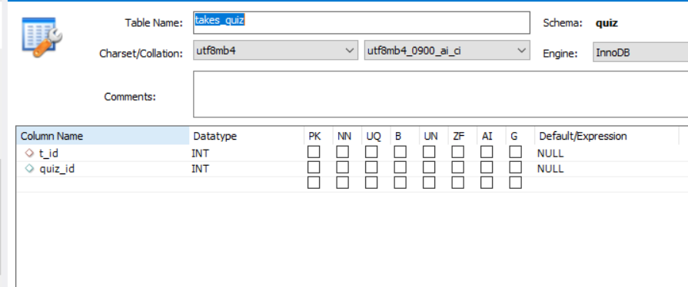

5.Result table

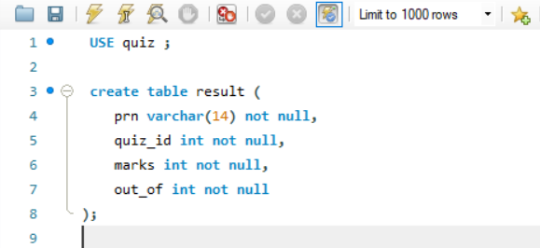

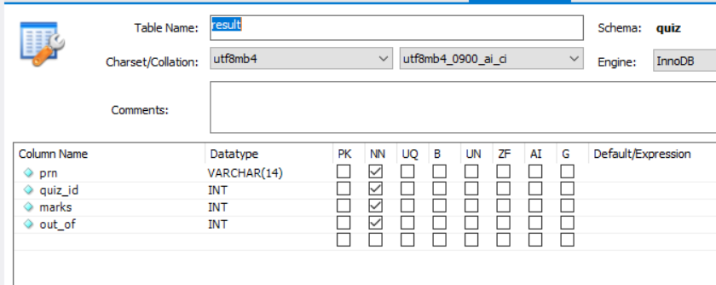

6. Attempted_students table

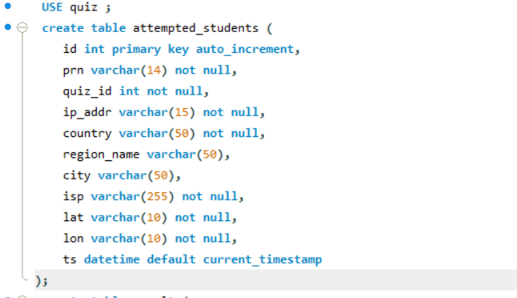

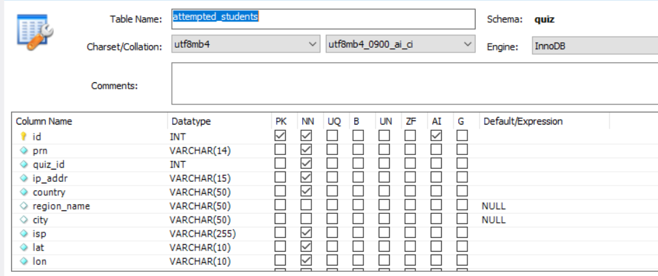

The first interface of the quiz app consists of a homepage that provides information about the app and allows users to register as either a student or a teacher. The homepage also provides options for logging in as a student or a teacher to access the quiz features.

If you are a student or a teacher looking to participate in quizzes, you can simply register by providing your basic details such as name, email address, and password. Once you have successfully registered, you can log in using your credentials to access the quiz features.

Registering as a Teacher :

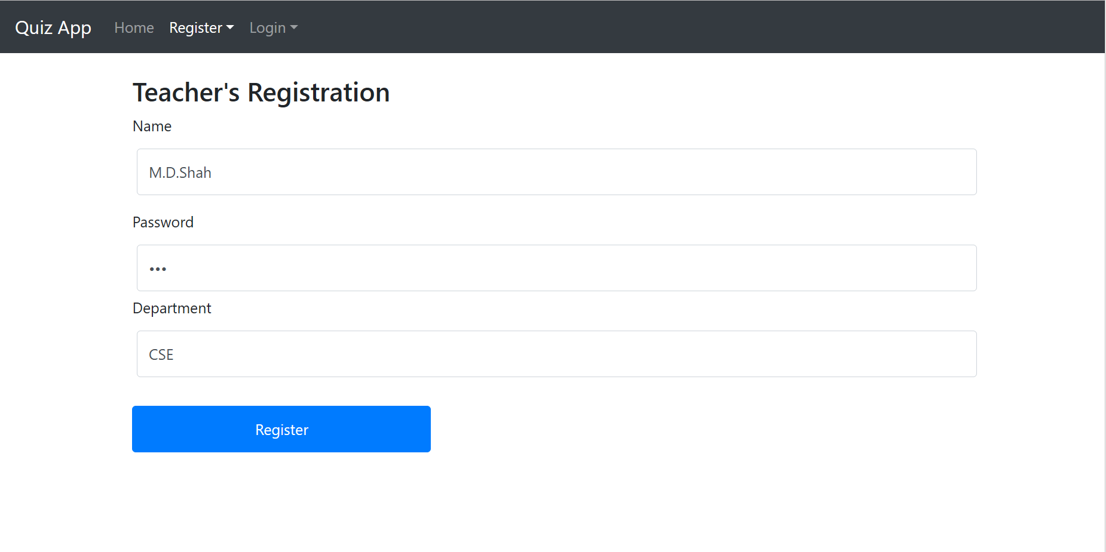

ID provided after Registering

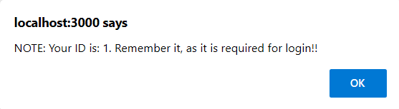

Login as Teacher with same credentials

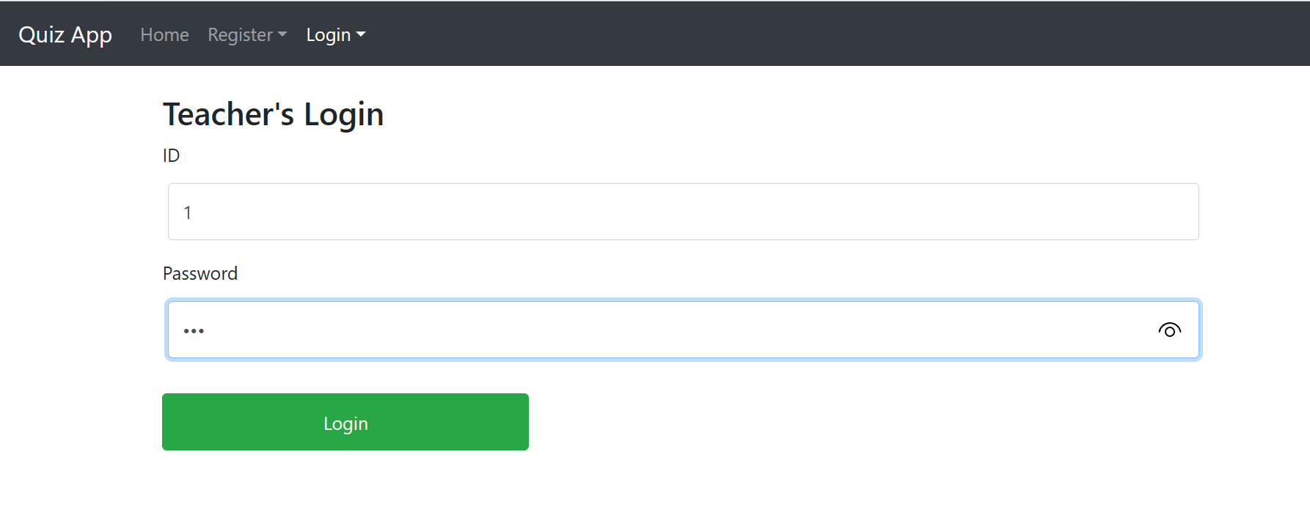

After logging in

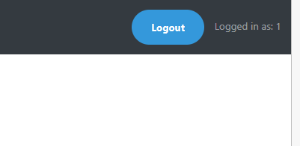

Create quiz option

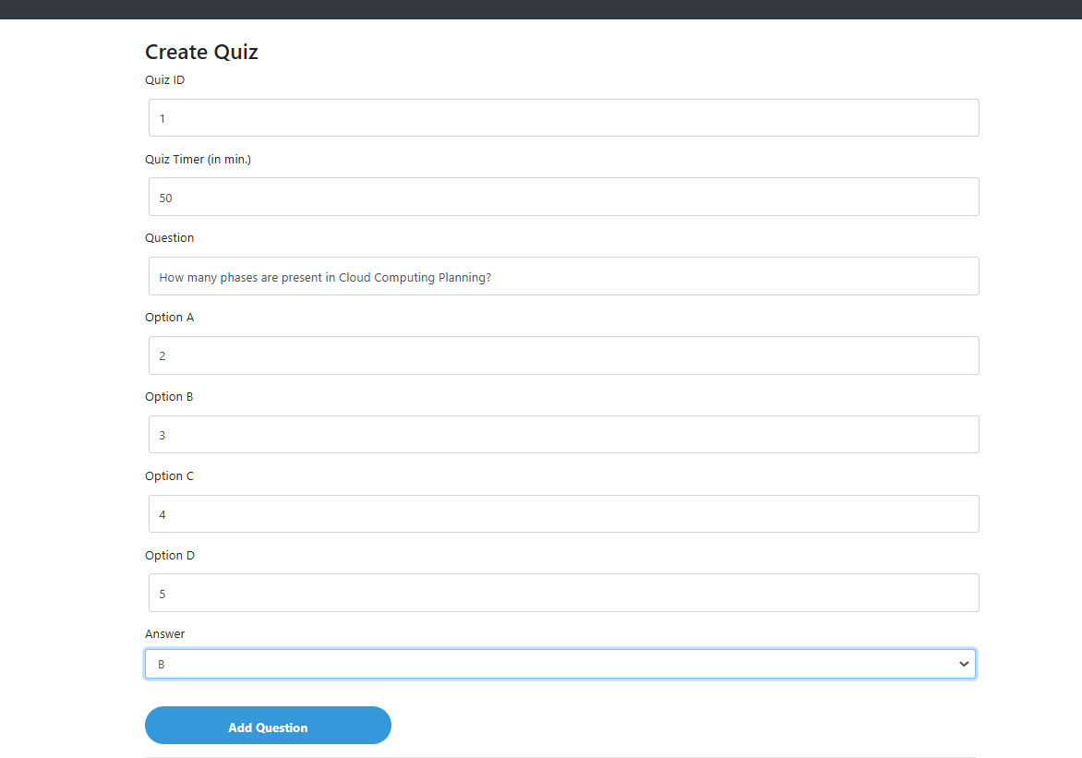

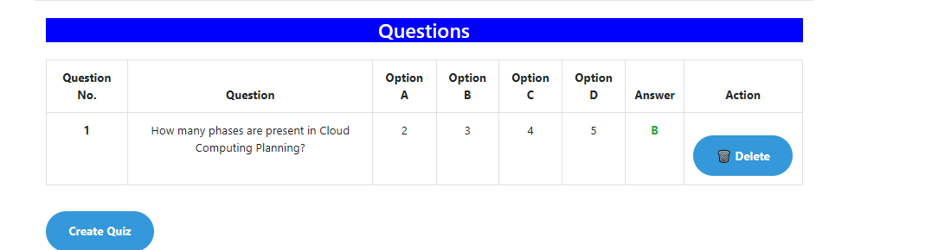

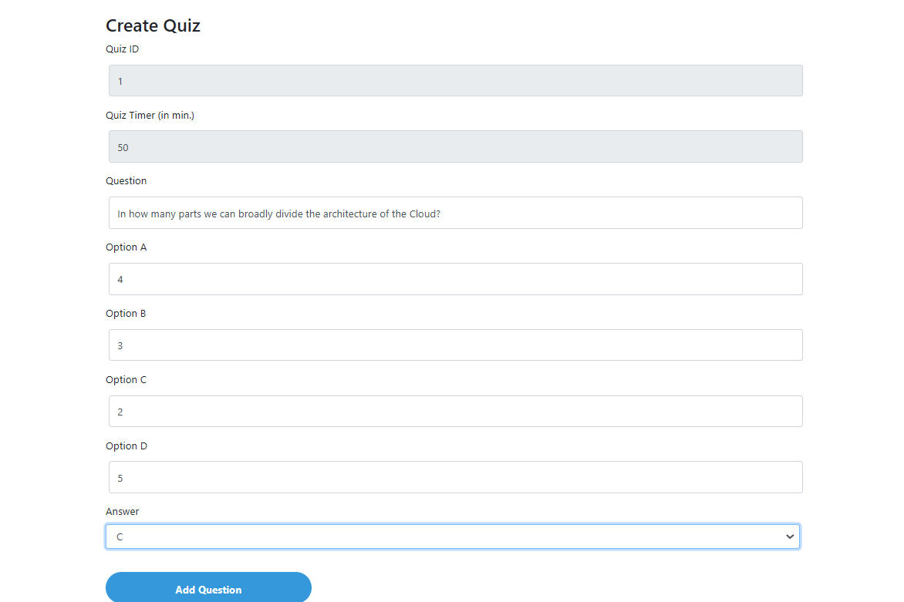

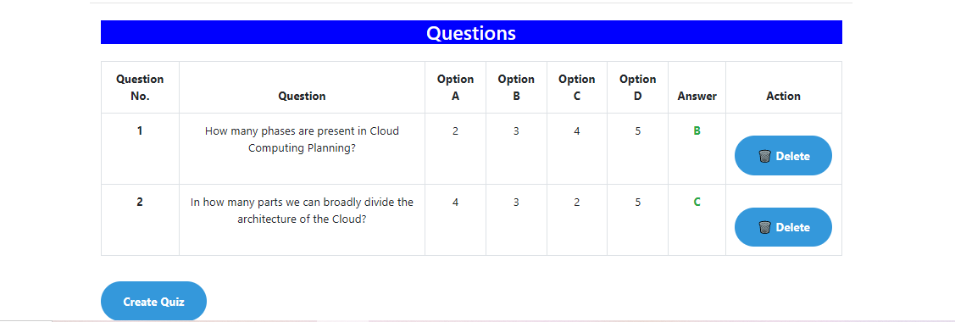

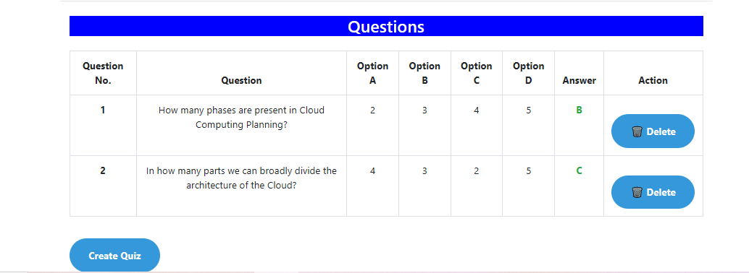



Creation of quiz

Student

Student registration

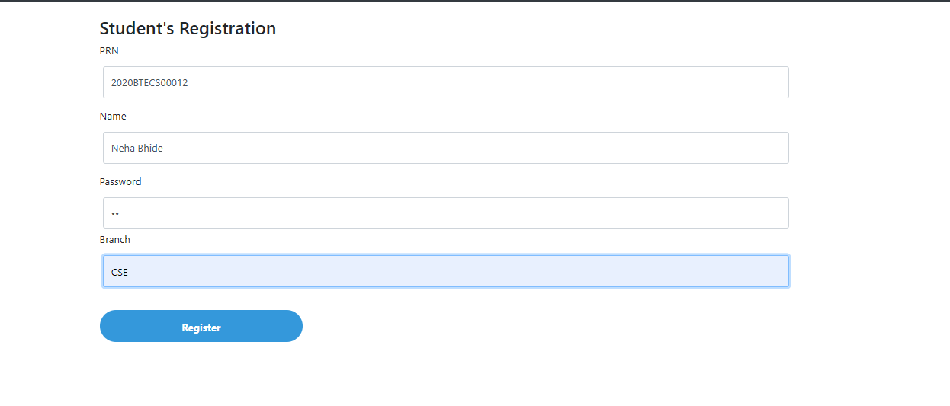 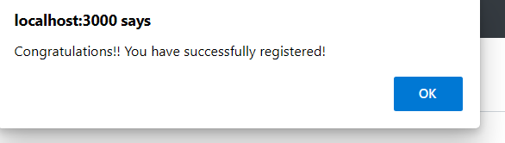

Logging in as a student

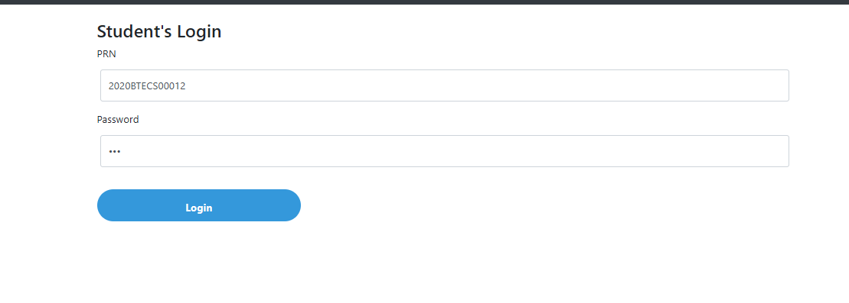

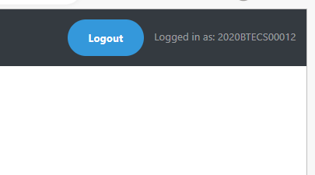

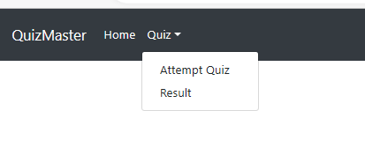

Attemp quiz

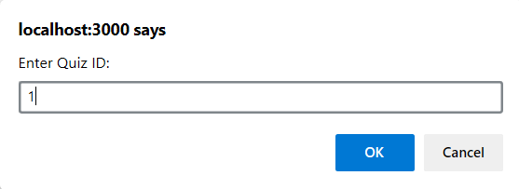

Giving quiz

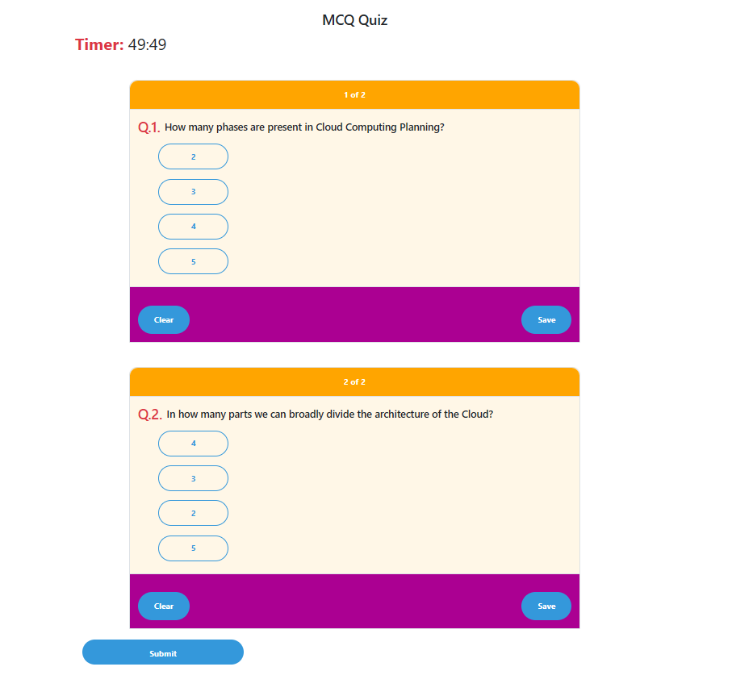

Answer selected ans saved

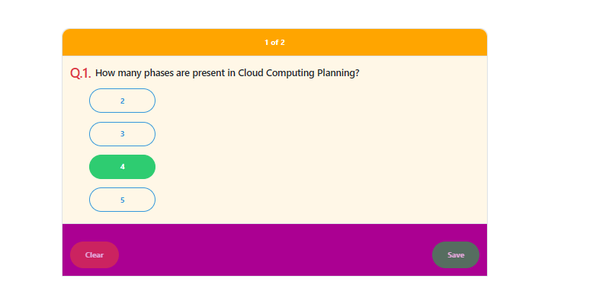 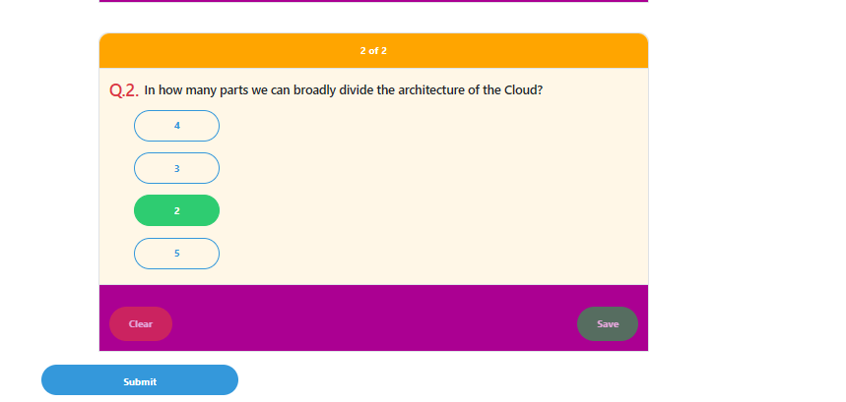

Submitting quiz

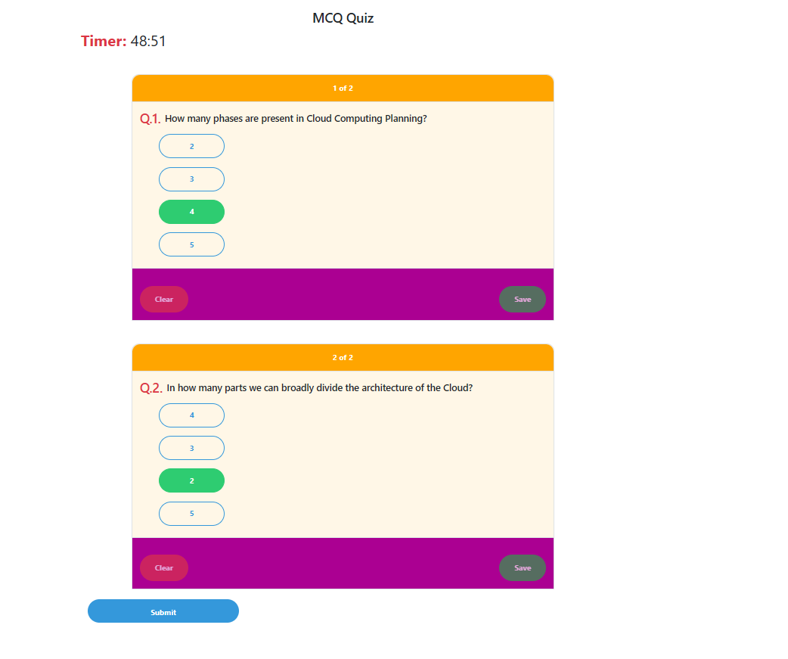





View Results ( as 1 of 2 was correct )

